# **Q1:**

CREATE TABLE TRAINEE

(

TraineeID int not null IDENTITY ,

Full_Name varchar(50) not null ,

Birth_Date date not null ,

Gender bit not null ,

ET_IQ int not null ,

ET_Gmath int not null ,

ET_English int not null ,

Training_Class char(10) not null ,

Evaluation_Notes nvarchar(max) ,

PRIMARY KEY(TraineeID) ,

CONSTRAINT ET_IQ_Check CHECK (ET_IQ BETWEEN 0 AND 20) ,

CONSTRAINT ET_Gmath_Check CHECK (ET_Gmath BETWEEN 0 and 20) ,

CONSTRAINT ET_English_Check CHECK (ET_English BETWEEN 0 and 50)

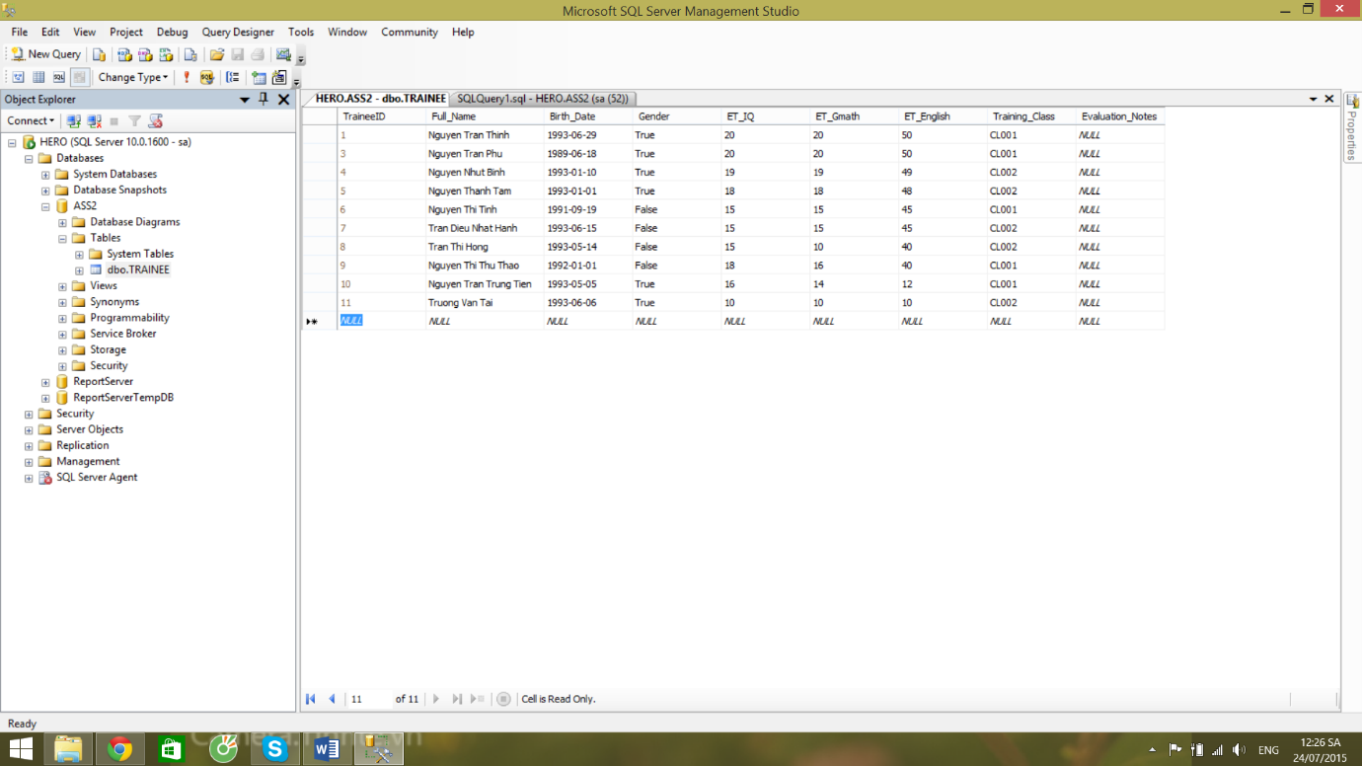)

# Q2:

ALTER TABLE TRAINEE ADD Fsoft_Account varchar(50) not null unique

# Q3:

CREATE VIEW PASSED

AS

SELECT *

FROM TRAINEE

WHERE ((ET_IQ + ET_Gmath) >= 20) and (ET_IQ >= 8) and (ET_Gmath >= 8) and (ET_English >= 18)

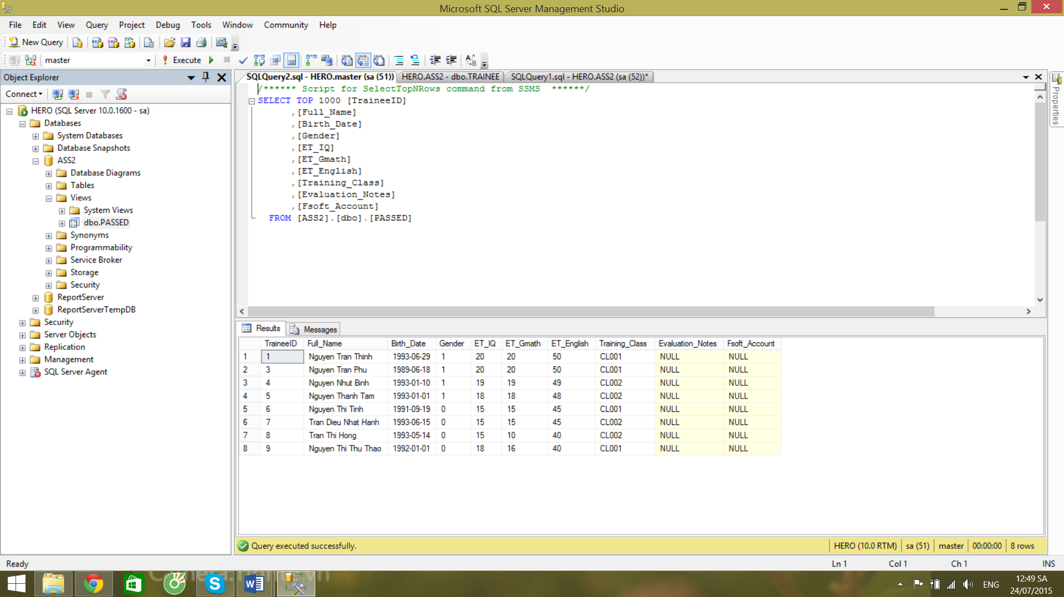

# Q4:

SELECT MONTH(Birth_Date) as Month , COUNT(TraineeID) as Quantity

FROM TRAINEE

WHERE ((ET_IQ + ET_Gmath) >= 20) and (ET_IQ >= 8) and (ET_Gmath >= 8) and (ET_English >= 18)

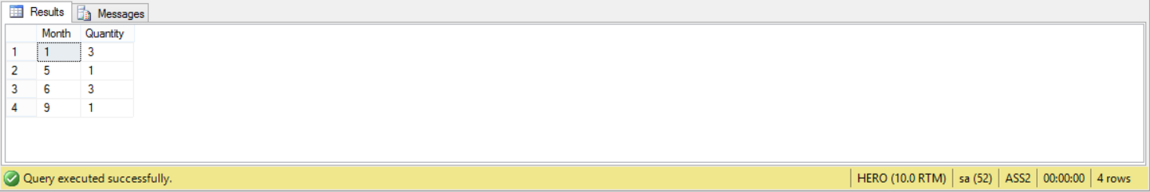GROUP BY MONTH(Birth_Date)

# Q5:

SELECT top 1 * , (YEAR(GETDATE()) - YEAR(Birth_Date)) as Age

FROM TRAINEE

ORDER BY LEN(Full_Name) desc

